Asia Sunday

2 June, 2019

Stateless and Trafficked People:

Our Co- Pilgrims
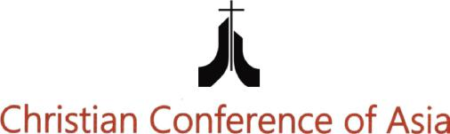


Asia Sunday is observed every year on the Sunday before Pentecost, and it coincides with the official inaguration of the Christian Conference of Asia. Asia Sunday observance focuses on a particular theme every year. This special occasion reminds member churches and councils as well as other partner churches and ecumenical organisations around the world to reflect on a specific Asian issue/ theme and organise worship services to offer special prayers. In 2019, Asia Sunday falls on 2 June, but as usual, churches and councils are free to choose a date, as per their convenience, to observe Asia Sunday in respective local or national contexts.

Stateless and Trafficked People:
Our Co- Pilgrims

“When an alien lives with you in your land, do not mistreat him. The alien living with you must be treated as one of your native-born. Love him as yourself, for you were aliens in Egypt. I am the LORD your God.”

(Leviticus 19:34)

“Don’t oppress an immigrant. You know what it’s like to be an immigrant,

because you were immigrants in the land of Egypt”

(Exodus 23:9)

“You are no longer foreigners and aliens, but fellow citizens with God’s people and members of God’s household...with Christ Jesus himself as the chief cornerstone. In him, the whole building is joined together and rises to become a holy temple in the Lord. And in him you too are being built together to become a dwelling in which God lives by his Spirit.” (Ephesians 2: 19-22)

3

Introduction

Statelessness and human trafficking are often intertwined, and are grave and widespread human rights problems of the contemporary world. Both issues have even been linked through the common claim that statelessness puts a person at greater risk of becoming a victim of trafficking. Millions of Asians, including women and children, are at risk of being stateless and trafficked as migrant workers both within and outside the region.

The stateless persons who are not recognised as nationals by any state have no nationality or citizenship and they live in vulnerable situations. As the stateless people living in particular geographical areas are not protected by any national legislation, the consequences of their situations of statelessness are profound. Statelessness affects all aspects of life and is a massive problem for twelve mil-lion people who are located in different parts of the world. These people be-came stateless due to various reasons and circumstances, mostly as a result of the denial of citizenship. In other cases political considerations dictated chang-es in the way citizenship laws were applied. Persecutions of ethnic minorities and discrimination of indigenous people, etc exist. There are also individuals who became stateless due to personal circumstances which they flee to neigh-bouring countries as a result of ethnic, religious or political reasons.

Stateless people exist in most Asian countries. Forty per cent of the identified stateless population of the world live in Asia and the Pacific. In South East Asia and South Asia, discriminatory laws, policies and practices on the basis of gen-der, ethnicity, race and religion have significantly contributed to statelessness. The Rohingyas in Myanmar are the most vulnerable stateless people in Asia. More than a million Rohinygas have been denied citizenship and subjected to persecution. Around one million of them live outside the country, many as refugees or illegal migrants in Bangladesh, India, Japan, Saudi Arabia, Malaysia, Thailand and Indonesia where they are vulnerable to deportation and live in impoverished conditions. Close to one million hill tribe people in Thailand lack Thai citizenship as they are unable to provide documentation of their birth-place or parentage. Children among the two million Myanmar refugees or economic migrants in Thailand are ineligible for Thai or Myanmar citizenship, rendering them stateless. Millions of people in Assam state of India have been

4

effectively made stateless by the Indian government’s recent actions, as the Indian government will no longer consider them as Indian citizens as they are not included in the draft list of the National Register of Citizens (NRC). Persons of Chinese descent have also faced restrictions on citizenship rights in Indo-nesia, Korea, and in Vietnam. Tens of thousands of undocumented children of migrant parents in Sabah in eastern Malaysia are believed to be stateless and extremely vulnerable, particularly those whose parents have been deported. Over 100,000 Bhutanese refugees in Nepal are among the most protracted situations of statelessness. Since being forcibly displaced during the Khmer Rouge regime in the 1970s, many ethnic Cambodians have lived in Vietnam for generations, and they have lost their documentation or any proof of hav-ing lived in Cambodia. This has resulted in their loss of lawful residence and nationality and they remain stateless. The Sama Dilaut, a migratory maritime people of Southeast Asia, is a group of people who face acute discrimination and risk of statelessness. Gender discrimination in nationality laws also cause statelessness in Asia especially in Nepal, Brunei Darussalam, and Malaysia. These countries continue to discriminate against women in their ability to con-fer nationality on their children or spouses.

Today, trafficking in persons thrives as modern-day slavery. The 2014 Global Slavery Index (GSI) found that there are nearly 36 million victims of human trafficking worldwide, of which 23.5 million, nearly two thirds, are from Asia. Trafficking for the purpose of sexual exploitation accounts for 58% of all cases detected globally, while trafficking for forced labour accounts for 36%. Women account for about 60% of trafficking victims, and children 27% (two thirds of them girls). Removal of organs, begging, forced marriages, illegal adoptions, participation in armed combat, and the commission of petty crimes are some of the other reasons for human trafficking. The UN estimates 2.5 million peo-ple are in forced labour, including sexual exploitation, of which 1.4 million are in Asia and the Pacific. The majority of trafficking victims are between 18 and 24 years of age. A large number of trafficked people also become ‘stateless’. It is identified that stateless people are significantly more likely to face labour exploitation. Young women are more at risk of becoming victims of labour exploitation as well as sexual exploitation.

5

As the consequences and impacts of statelessness and human trafficking are enormous, the Christian response warrants to address this menace with ur-gent priority. It is important to care for migrants, trafficked and stateless as the human family is intimately connected or interdependent. There are numerous issues linked to movement of people within and beyond borders, especially the rampant rise of inequality, ethnocentrism, racism, violence and extreme na-tionalism. All these dehumanising factors are degrading the image of God and the basic dignity deserved by every human being created in the image of God. The Christian response and witness, therefore, require to protect the basic dig-nity. The Church as an instrument of caring for God’s creation must protect those who have been trafficked to exploitation and those who are forced to live in our midst as stateless. Our response must also address rescue and rehabili-tation the victims of human trafficking as well as protection of the rights of the stateless and reintegrate them back into their community to lead a meaningful and dignified life.

Asia Sunday is observed every year on the Sunday before Pentecost, and it co-incides with the date of the inaugural assembly of the Christian Conference of Asia. The Asia Sunday this year will be observed on 2 June 2019. The member churches and councils of CCA, as well as churches and ecumenical partners around the world, observe Asia Sunday as an occasion to offer special prayers and worship services with focus on a special theme pertinent to the Asian context. The CCA, in this context, has decided to focus the theme of the Asia Sunday-2019 on ‘Stateless and Trafficked People in Asia: Our Co-Pilgrims’. It is our prayer and hope that the churches and the ecumenical family will take ini-tiatives to plan and organise the Asia Sunday -2019 in a most befitting manner.
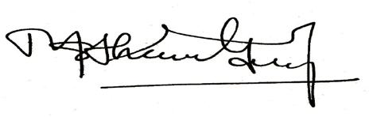

Mathews George Chunakara
General Secretary, CCA

6


ASIA SUNDAY-2019
Order of Worship

Opening Response

Leader (L): We come to worship God in our need, bringing with us the needs of the world.

People (P) : We come to God, who comes to us in Jesus, and who know by experience what human life is like.

- We come with our faith and with our doubts, we come with our hopes and with our fears.

- We come as we are because it is God who invites us to come, and God has promised never to turn us away.

- Lord, we remember the plight of the stateless and trafficked people in our world;

They are forgotten and the excluded;

They are the people without citizenship, stripped of their rights and dignity.

- Lord, help us to realize they are our co-pilgrims, and fellow citizen in God’s household.

- Lord, how cruel is our world where nearly 20 people are forcibly displaced every minute as a result of conflict or persecution;

We are told that an unprecedented 65.6 million people globally have been forced from their homes; among them are nearly 22.5 million refugees, 10 million stateless people are denied a nationally and access to basic movement.

- Lord, help us to realize they are our co-pilgrims and fellow citizens in God’s household.

7

- Lord, we are here to remember our brothers and sisters who are trafficked, the stateless, migrants;

- We also remember and pray for those who are refugees and internally displaced.

- God calls us to love one another. As a sign of that love, let us lift up our prayers to God for the needs of all people throughout the world.

- Lord, help us to realize they are our co-pilgrims and fellow citizens in God’s household.

All: O God, in your mercy, hear our prayer.

L: Let us join our hearts and voices to offer our prayers to God.
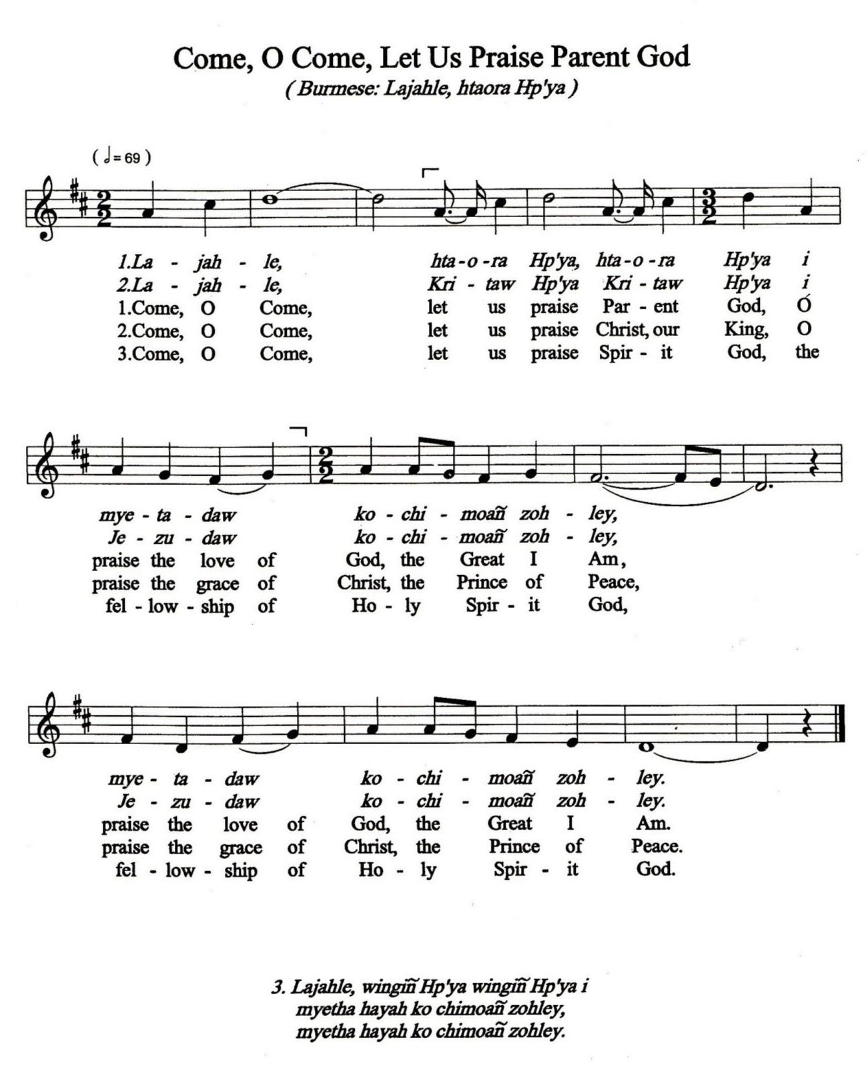

8

Prayer

L: O Jesus, who as a child was carried into exile,

- remember all those who are deprived of their home or country,

- who groan under the burden of anguish and sorrow,

- enduring the burning heat of the sun,

- the freezing cold of the sea, or the humid heat of the forest,

- searching for a place of refuge.

- Cause these storms to cease, O Christ.

- Move the hearts of those in power,

- that they may respect the men and women whom you have created in your own image,

P: that the grief of refugees may be turned into joy.

Confession of Sins

- Jesus, friend of sinners, Your words to Your disciples were plan: Whatever we did for the least of our brothers and sisters, we did for You, But, have we fed the hungry?

Have we invited in the strangers?

Have we clothed those whose garments were threadbare? Have we looked after the sick?

Have we visited the incarcerated?

P: Merciful God, forgive our sins, and renew us. Amen.
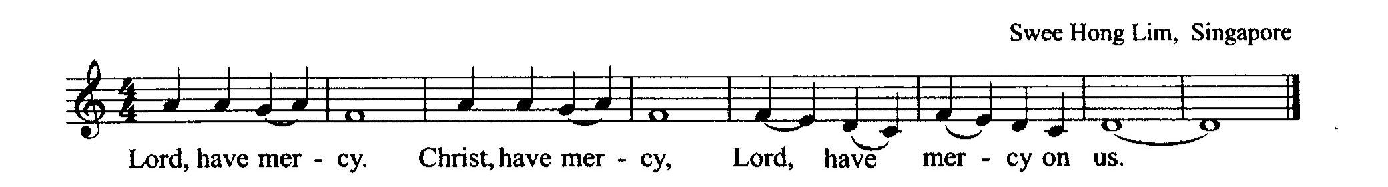

Stories

- “When we heal the wounds of refugees, displaced persons, and victims of trafficking, we are practicing the commandment of love that Jesus has left us. Their flesh is that of Christ.” (Pope Francis)

9

Reader 1: Despite the hazards of migration, Saniyi (13 when she migrated) exhibits the unrelenting hope of so many migrants. Saniyi lived in chronic poverty in Myanmar, a stateless child of a stateless single mother. She had heard stories of girls in Malaysia who sent money to their family, so when a relative asked if she wanted to become a babysitter in Malaysia, she said “yes.” Captured by traffickers, she was confined in a Malaysian trafficking agent’s residence where she was constantly harassed by one man. She was forced to sell tissue packets on the street with a daily quota required to avoid a beating, but she was arrested with a group of street children for illegal selling.

Reader 2: Vietnamese boy is forced by his family to work at a local brick factory. He labours everyday carrying 40 pound loads of bricks on his head and engages in other hard physical labour. The owner of the brick factory insists that he has to work for another two years to satisfy the outstanding debt owed by his parents.

Reader 3: The ethnic Muslim minority Rohingya’s citizenship right is stripped; and there are restrictions imposed on their freedom of movement, health care and medical facilities, education, land and property ownership, marriage, and employment. They are treated only as illegal immigrants despite residing in Myanmar for centuries. Mistreated in the country where they were born and consider home, they are even neglected by the neighbouring countries. The Rohingyas live in dire poverty and unsafe situations in Myanmar, Bangladesh, India, Malaysia and Thailand.

Reader 4: Alwyn, A Karen refugee in Mae La camp on the Thailand-Myanmar border says: “Many of us were born in the refugee camps and have never been to Myanmar. We suffer due to the serious confusion of our identity; we will not be welcomed in Myanmar as we are stateless aliens in Thailand”.

Reader 5: Sex trafficking is particularly rampant within Nepal and India, with as many as 5,000-10,000 women and girls trafficked to brothels in India alone each year. Those who have been trafficked for sex work are illiterate, and have fewer family members with earning power, Younger female children, on the other hand, tend to also be exploited for non-sex work including domestic and manual labour, and work for circus entertainment companies. The younger the girl, the higher the price she will be sold for.

10

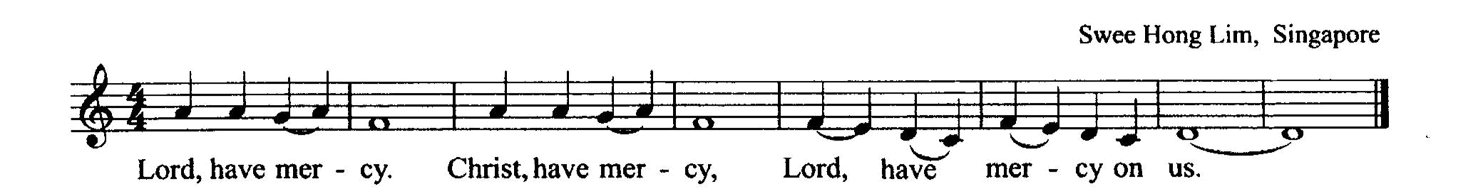

[Moment of Silence]

- May human dignity be restored to those who have been bought, sold or kinapped for the monetary benefit of others.

P: Restore our community.

- For those in bonded labour, in agricultural fields, mines and factories who have been reduced to tools of production, commodities than human beings.

P: Restore our community.

- For those who cannot return home due to stigma of prostitution, disease or shame, that they receive the solace, healing and support they need.

P: Restore our community.

- For women who are estimated to make up 80% of human trafficking victims, and for changes in societal attitudes that deny the equality and dignity of women.

P: Restore our community.

L: For victims of trafficking and the stateless in our own local communities. May we have eyes to embrace them and to love them in the way that God love them.

P: God!
Help us to overcome our reluctance, our divisions, and our feelings of powerlessness,
so that we may stand as one in solidarity

with our brothers and sisters in the human family.

11

Together, open our hearts and hands and our minds to find a way to the freedom that is your gift to every child, every women, and every men.

We pray for all the forms of violence and injustice increasing the numbers of trafficked, stateless, migrants and refugees to end. Amen.

Lord’s Prayer ... All together

Hymn … Jesus, Savior Lord, lo to you I Fly
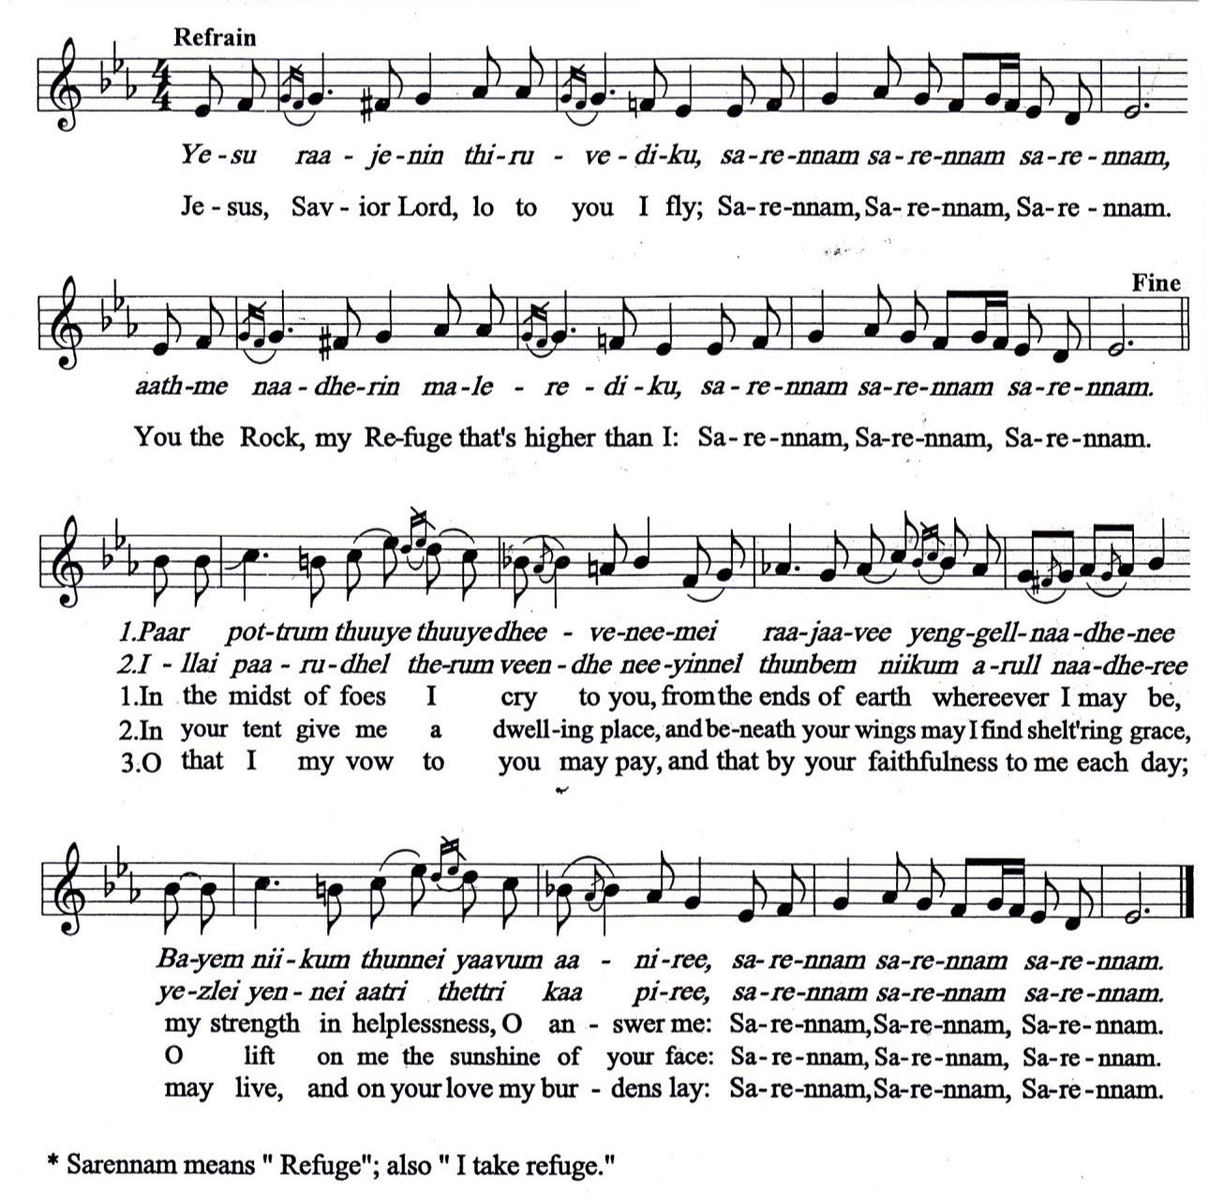

Scripture Reading

12

Leviticus 19.34

When an alien lives with you in your land, do not mistreat him. The alien living with you must be treated as one of your native-born. Love him as yourself, for you were aliens in Egypt. I am the LORD your God.
Exodus 23.9

Don’t oppress an immigrant. You know what it’s like to be an immigrant, because you were immigrants in the land of Egypt.

Ephesians 2.19-22

You are no longer foreigners and aliens, but fellow citizens with God’s people and members of God’s household...with Christ Jesus himself as the chief cornerstone. In him, the whole building is joined together and rises to become a holy temple in the Lord. And in him you too are being built together to become a dwelling in which God lives by his Spirit.

Reflection/Sermon

Hymn … O Many People of All Lands
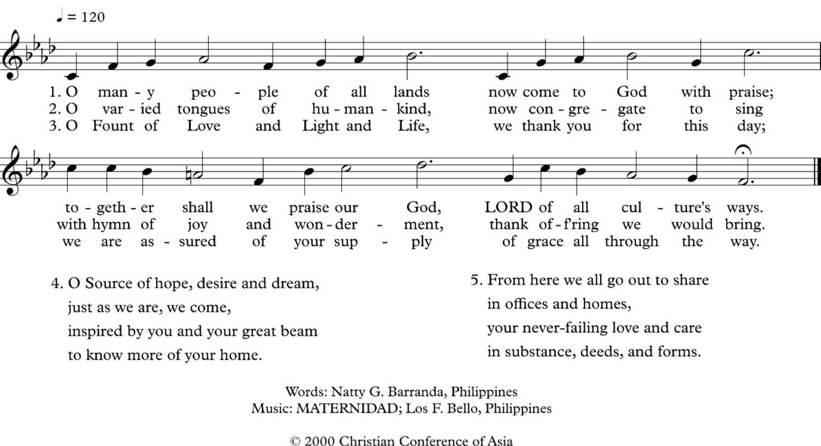

13

P: Merciful God,
We pray for all whose desperation leads them to the sea, to undertake perilous voyages,
often following dangerous journeys over land:
those escaping brutal wars,
those fleeing religious persecution,

those escaping climate disasters and economic ruin, those looking for hope in a hopless situation. May we look beyond our own fears and concerns

to the needs of those who have nothing, risk everything and depend on the kindness of strangers. May our hearts be opened,
our leaders be challenged
and our self-interest be called out.

Amen.

L: Lord,
When you multiplied the loaves and fishes, you provided more than food for the body.

You offered us the gift of yourself, the gift which satisfies every hunger and quenches every thirst.

Your dsiciples were filled with fear and doubt, but you poured out your love and compassion on the migrant crowd, welcoming them as brothers and sisters. Lord Jesus, today you call us to welcome the members of God’s family who come to our land to escape oppression, poverty, persecution, violence, and war.

Like your disciples we too are filled with fear and doubt and even suspicion.

P: Lord, forgive our failures of building barriers in our hearts and in our minds.

- Lord Jesus, help us by your grace; to banish fear from our hearts that we may embrace each of your children as our own brother and sister; to welcome migrants and refugees with joy and generosity, while responding to their many needs;

to realize that you call all people to your holy mountain to learn the ways of peace and justice;

to share of our abundance as you spread a banquet before us;

to give witness to your love for all people, as we celebrate many gifts they bring.

14

- We praise you and give you thanks for the family you have called together from so many people. We see in this human family a reflection of the divine unity of the one Most Holy Trinity. Amen.

- God, no one is stranger to you and no one is ever far from your loving care. In your kindness watch over the trafficked, the stateless, migrants and refugees, those separated from their loved ones, those who are lost,

and those who have been exiled from their homes. Bring them safely to the place where they long to be,
and help us always to show your kindness to strangers and those in need. We ask this through Christ our Lord,

who too was a refugee and migrant

who travelled to another land searching for a home. In the name of our Lord Jesus we pray.

- Amen. Offertory
Hymn … Living in Christ with People
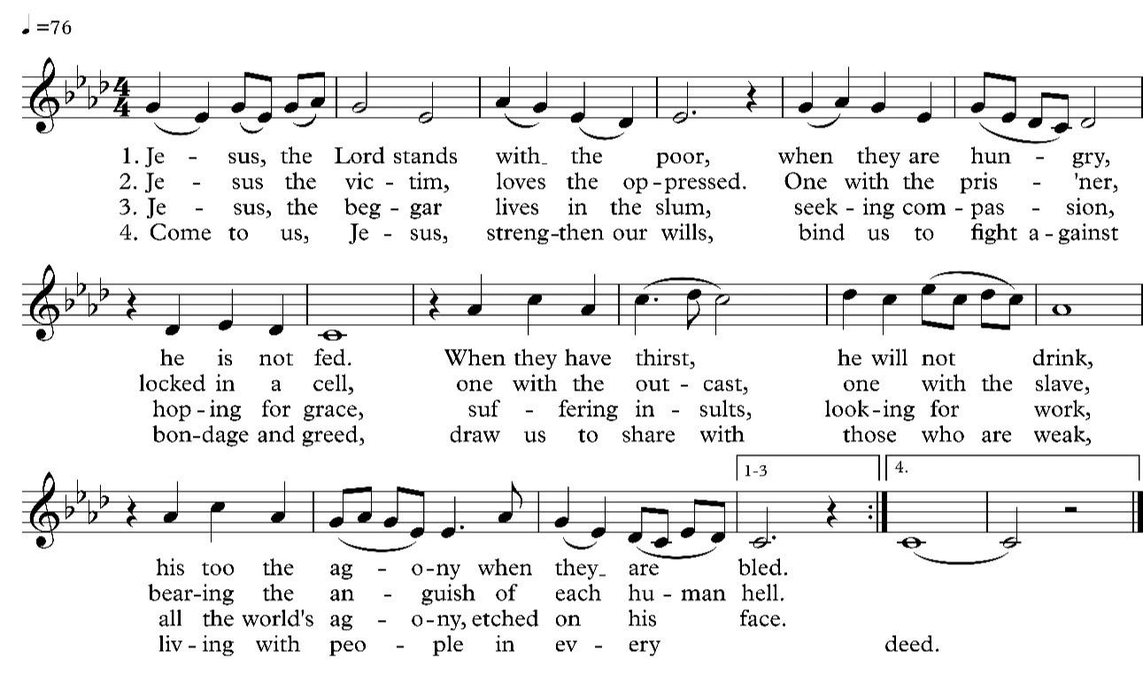

15

“The Spirit of the Sovereign LORD is on me, because the LORD has anointed me to preach good news to the poor. He has sent me to bind up the broken hearted, to proclaim freedom for the captives and release from darkness for the prinsoners, to proclaim the year of the LORD’s favor and the day of vengeance of our God, to comfort all who mourn, and provide for those who grieve in Zion- to bestow on them a crown of beauty instead of ashes, the oil of gladness instead of mourning, and a garment of praise instead of a spirit of despair.” (Isaiah 6:1-3)

Voice 1: Who Am I?
I am a woman/man.
I am a live.
I am struggling.
I am hoping.

I am created in the image of God just like all other people in the world; I am a person with worth and dignity.
I am a thinking person, a feeling person, a doing person.

I am a worker who is contantly challenged and faced with the needs of the church and society in Asia and in the global community.

I am angered by the structures and powers that created all forms of oppression, exploitation and degradation.

I am a witness to the moans, tears and clenched fists of my people. I can hear their liberating songs, their hopeful prayers and decisive march toward justice and freedom.

I believe that all of us - women and men, young and old, Christian and non-Christian are called upon to do responsible action:
to be concerned,
to be involved,
NOW!
I am hoping.
I am struggling,
I am alive,
I am a woman/man. (Elizabeth Tapia)

Voice 2: What will we say to those amassed on the margins of privilege and power.

16

Voice 1: Rise up, all you who are oppressed.

Voice 2: We praise you, Lord, for preferring to be on the side of the disadvantaged.

Voice 1: Open your eyes;
Help us to see the wounded all around us.

- We stand in solidarity with all who resist courageously the injustices in their lives.

Voice 2: Thank you, Lord, for sending us forth and for bringing us back undefeated.

Voice 1: We trust in the One who gives new life to all who have been mistreated. All: God, empower us and remain within us. Prayer of Invocation

All: Lord, we stand beside our brothers and sisters who are stateless, trafficked, migrants and refugees.

We know your bear their terrible fear, hurt and pain.

We pray for justice to be served.
We pray for their release from the unbearable dehumanization, anguish and humiliation they feel.
We pray for their liberation from being held captive against their will.
We pray for their healing.

We pray you will use us in some way to help end this human tragedy.

Lord, we have faith that your presence, your love, and your spiritual embrace will always be with all your people in need.

May they feel your peace and grace.
Lord, God, hear our prayer.

In the name Jesus Christ, we pray, Amen.

17

Benediction

The love of God be the passion in your heart.
The joy of God your strength when times are hard.

The presence of God a peace that overflows.
The Word of God, the seed that you might sow.
Amen.

18

You are encouraged to make a special Asia Sunday

offering and contribute to

CCA’s Asia Solidarity Fund.

 | CCA Bank Account Details
Account Name | : Christian Conference of Asia
Bank | : Han Seng Bank
Branch | : Hankow Road (4 Hankow Road Kowloon,
 | Hong Kong SAR, China)
Account No. | : 295-4-709594
Account Type | : Multi-currencies Account
Swift Code | : HASEHKHH

19

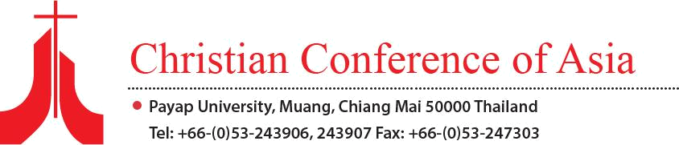

20

