Asia Sunday

16 May 2021

I am the Lord

who Heals You and Restores Your Health

Foreword

Asia Sunday is observed every year on the Sunday before Pentecost, and it coincides with the official inauguration of the Christian Conference of Asia. Each year’s observance of Asia Sunday is marked by a focus on a specific theme. This special occasion reminds member churches and councils as well as other partner churches and ecumenical organisations around the world to reflect on a theme and hold worship services to offer special prayers relating to that area of concern.

The theme we have chosen and suggested for the observance of Asia Sunday in 2021 is “I am the Lord who Heals You and Restores Your Health”, based on the biblical verse Exodus 15:26. This theme is very relevant in today’s global situation when COVID-19 continues to aggravate the vulnerability of humanity. God the creator, the provider, and the sustainer has progressively revealed the many facets of God’s eternal character throughout history. Through the assurance, “I am the God who heals you”, the Almighty and everlasting God shows His love and care for all God’s creation.

God, who heals the physical wounds and earthly diseases that trouble the mortal bodies of His people, assures all those who are disturbed in their minds and emotions and whispers into their hearts: “My grace is sufficient, for My strength is made perfect in your weakness…in your sickness, in your hardship—in your loss, and your pain.” His grace is always sufficient for us. The imperishable truth is that His healing touch also spans the eternal sphere and the spiritual realm. God's gradual unveiling of His plans and assurances has been progressively revealed in history. His eternal plan of redemption, which is perfected and completed in the Lord Jesus, always reminds us that God heals us, takes care of us in our vulnerability, and restores us.

The observance of this year’s Asia Sunday is designated as a special occasion to once again pray for all who are suffering due to the COVID-19 pandemic. Since the outbreak of COVID-19 more than a year ago, millions of people have been infected due to the novel coronavirus, which has left a trail of death and devastation around the world. Vaccines for COVID-19 are now being tested in several parts of the world, but the onslaught of COVID-19 continues—even as the pandemic is now believed to be easing in some countries. However, the worsening situation of mass virus transmission is forcing fresh lockdowns in European nations as they grapple with new waves and variants. As we observed last year, “the crucial conditions which we are currently collectively undergoing is also a reminder for humankind to reflect on the fragility of human life and the ultimate vulnerability of the entire cosmos!” Our world continues to need prayers, cure, and healing.

Let us continue to pray together, without losing hope, for God’s mercy and healing for the sick, and for health and strength for all who care for them. In 2021, Asia Sunday falls on 16 May. We urge all member churches and councils of CCA as well as our ecumenical partners and churches around the world to use this special liturgy in the coming days for their prayers, and also especially on 16 May 2021.

Let us be strengthened by our faith and hope in God who assured us: “I am the Lord who Heals You and Restores Your Health.”

Mathews George Chunakara

General Secretary, CCA

Asia Sunday – 2021

“I am the Lord who Heals You and Restores Your Health”
(Exodus 15:26)

Call to Worship

LEADER (L): God invites us to experience God’s healing presence as we listen to these words:
“I am the Lord, who heals you.”
God calls us to open our eyes, hear with our ears, and turn our hearts towards God, the Great
Physician.
CONGRGATION (C): We come to You, God, in faith—yearning for Your healing touch on our bodies,
minds, and souls.

L: God often heals the physical wounds and earthly diseases that trouble our mortal bodies and play heavily on our minds and emotions, but often God whispers into our hearts, “My grace is sufficient, for My strength is made perfect in your weakness...in your sickness, in your hardship—in your loss, and your pain.”
C: We come to You, God, in faith—yearning for Your healing touch on our bodies, minds, and souls.

L: God, our Healer, who enabled Your servant Job to overcome his great suffering without denying your name, power, and love.
C: Have mercy on us who are stricken by the pandemic.

L: God, stretch out Your healing hand and hold back this virus. Strengthen and comfort those who are infected and ease their pain of body and mind. Send Your Holy Spirit to restore us all, and lead us into repentance and faith in the gospel. Have mercy on us, God, and on the sick throughout the world.
C: God, fill us with the warmth of Your love and compassion. Amen.

Hymn … O Christ, the Healer, We Have Come

Prayer I.
We are grateful for the gift of Your love that that dwells and abides in our lives. As Your creation, we are grateful that Your works are truly beautiful; we are of different ages, abilities, colours, places, traditions, cultures, and even ecclesiastical denominations, but we are one in glorifying God the Creator.
Our Lord and Saviour, make us worthy enough to enjoy the redemptive work of Christ our Lord and Saviour. We pray that our weakness and sin are no longer a hindrance for us to enjoy Your grace in our lives.
As Your people, we are on a pilgrimage in this world, in the belief that You are always with us throughout our journey. In times of suffering, sorrow, difficulty, and pressure, You are present as the true Spirit of strength and comfort.
We believe that everything that happens in this life is under Your authority and in keeping with Your loving plan.
We thank You, gracious God. You have loved us from the beginning of time and remembered us when we were in trouble. Your mercy endures forever.
We thank You, redeeming God. You have come to us in Jesus Christ, who heals us and saves us from sin. Your mercy endures forever.
We thank You, holy God. You have sent us Your Spirit to comfort us and lead us all into truth. Your mercy endures forever. Gracious, redeeming, and holy God, glory and praise be Yours.
Amen.

Prayer II.
Merciful God, we come to You at this time of our travail and anxiety.
We pray for all who suffer from the coronavirus.
We pray for Your divine touch upon all those who are infected around the world.
We pray for Your healing presence in the midst of their sickness and discomfort.

God Almighty, may they receive proper treatment and care; may their caregivers, families, and neighbours be shielded from the outbreak of the virus.

Lord, the great Healer, protect and guide those who strive to recover from their illnesses.

God of the universe, the great Comforter and Sustainer, we pray for solace and comfort for those who grieve the loss of their loved ones; help them to rise above bereavement and fear, and overcome anxieties. May they be protected from the forces of evil and be restored to their communities in wholeness and health.

We ask all these in the name of Jesus Christ,

All:
Amen.
Lord, we are reminded of Your assurances that
“You shall not fear the terror of the night
nor the arrow that flies by day,
nor the pestilence that roams in darkness,
nor the plague that ravages at noon.” (Ps 91:5-6)

Isaiah 40:26–31
Lift your eyes and look to the heavens: Who created all these?
He who brings out the starry host one by one,
And calls them each by name.
Because of his great power and mighty strength, not one of them is missing.
Why do you say, O Jacob, and complain, O Israel, “My way is hidden from the Lord;
My cause is disregarded by my God?”
Do you not know? Have you not heard? The LORD is the everlasting God, the Creator of the ends of the earth.
He will not grow tired or weary, and his understanding no one can fathom.
He gives strength to the weary and increases the power of the weak.
Even youths grow tired and weary, and young men stumble and fall;
But those who hope in the LORD will renew their strength.
They will soar on wings like eagles; they will run and not grow weary, they will walk and not be faint.

Prayer III.
O God,
We rest underneath Your mighty wings of love. We dwell within Your gentle heart. We know there is healing in Your touch. Through the sufferings of Christ, we ask for restoration and trust in Your goodness. You are our Lord, our Saviour, our Healer, and our Friend. We dwell within Your gentle embrace.
Amen.
Prayer IV.
God of the present moment,
God, who in Jesus stills the storm and soothes the frantic heart, bring hope and courage to all who remain in uncertainty.
Bring hope that you will make us the equal of whatever lies ahead.
Give us the courage to endure what cannot be avoided, for Your will is health and wholeness;
You are our God, and we need You.
Amen.

Prayer V.
Jesus Christ, you travelled through towns and villages, curing every disease and illness. At Your command, the sick were made well.
Come to our aid now, in the midst of the global spread of the coronavirus, that we may experience Your healing love.
Heal those who are sick with the virus. May they regain their strength and health through timely and quality medical care.
Heal our fear, which prevents nations from working together and neighbours from helping one another.
Heal our pride, which can make us claim invulnerability to a disease that knows no borders. Jesus Christ, Healer of all, stay by our side in this time of uncertainty and sorrow.
Be with us as we worry in fear, defend us from illness and despair. May we know Your peace.
Amen.

Hymn … In Faith and Hope and Love
Lamentation
L: God!
We confess our need for You today.
We need Your healing and Your grace.
We need Your strength to regain our health.
We need hope restored.
We need to be reminded that You work on behalf of those You love, constantly, powerfully, completely.

C:
Forgive us for trying to fix our situations all by ourselves.
Forgive us for running in different directions and spinning our wheels to find help, when true help and healing must be found first in You.
Forgive us for forgetting how much we need You, above everyone and everything else.
We come to You and bring to You the places where we are hurting.
You see where no one else can fully see or understand.
You know the pain we have carried; the burdens, the cares.
You know where we need to be set free.
We ask for Your healing and grace to cover every broken place, every wound, every sickness.
We are grateful that You can do far more than we could ever imagine.
Thank You for Your Mighty Power that acts on behalf of Your children.
We reach out to You and know that You are restoring and redeeming every place of difficulty, every battle, for Your greater glory.
We know that our pain and suffering will never be wasted.
We love You. We need You today.
Amen.

Assurance
Beloved, I pray that all may go well with you and that you may be in good health, as it goes well with your soul. For I rejoiced greatly when the brothers came and testified to your truth, as indeed you are walking in the truth. I have no greater joy than to hear that my children are walking in the truth. (3 John 1:2–4)

Scripture Reading

Isaiah 57:18-19

I have seen their ways, but I will heal them; I will guide them and restore comfort to Israel’s mourners, creating praise on their lips. Peace, peace, to those far and near,” says the LORD. “And I will heal them.”
Jeremiah 30:17
“But I will restore you to health and heal your wounds,” declares the LORD.

3 John 1:2
“Dear friend, I pray that you may enjoy good health and that all may go well with you, even as your soul is getting along well.”
Revelations 21:4
“He will wipe every tear from their eyes. There will be no more death or mourning or crying or pain, for the old order of things has passed away.”

Homily
People’s Voices Amidst the Pandemic

Voice 1: At this crucial time when people need mutual solidarity and support, we commit the churches in Asia, so that together with other faith communities they come forward in unity and cooperate with governments and health workers in the struggle to change the trajectory of this pandemic.
General Secretary, Christian Conference of Asia

Voice 2: In Hong Kong, 98 per cent of domestic household workers are women. Both social unrest and social distancing have led to a worsening situation of domestic workers, as they have to stay in the residence of their employers all the time, as a result of which they lack privacy and work more hours.
Centre for Migrant Domestic Workers in Hong Kong

Voice 3: The COVID-19 crisis forced around 80,000 Cambodian migrants to return home from Thailand. The loss of income pushed many families into micro-finance debts and the women of such families are being exploited by private moneylenders. COVID-19 has serious implications for both the short- and long-term, making vulnerable communities the target of social and political exclusion, isolation, and stigmatisation.
Alliance for Conflict Transformation, Cambodia
Voice 4: Indigenous peoples are among those who were the hardest hit by the induced global recession, extreme poverty, and escalating rates of malnutrition. The pandemic truly highlights how the failure to recognise the collective dimension of indigenous peoples’ rights can result in the lowering of the resilience of many indigenous communities to the health and economic impacts of the global crisis.
UN Special Rapporteur on the Rights of Indigenous Peoples

Intercessory Prayers

L: Healing God, restore us.
We cry out to you, our God.
You alone are our refuge. You alone are our hope. We come to You.
Restore our tiredness and weakness. Pour out Your loving Spirit over us.
We need the tenderness of Your healing hands.
We are lost, but we are singing; because You gave us life and the gift of infinite joy. Give us the strength to move forward on the path You have laid out for us. Guide us towards better health, and restore our strength and spirit.
C: O Lord, bring Your healing and Your peace!

L: Christ, our Lord and Saviour,
In times past, many servants of Yours brought their friends and loved ones to Your side, that they might
be blessed and healed.
This COVID-19 pandemic has unleashed untold suffering upon the world, causing disease and death to
millions of people and wreaking havoc on the economy.
Look with compassion upon Your people, and all people are Your people who need Your loving touch.
Heal the sick, save the dying, comfort the bereaved, and give eternal rest to the dead.
C: O Lord, bring Your healing and Your peace!

L: God of all creation, You meant for us to be a single people; ruled by love, justice, freedom, and peace.
Help us to realise that in these times of pandemic, we are all together and mutually in need of each
other’s support, accompaniment, and prayers for grace.
C: O Lord, bring Your healing and Your peace!

L: We pray for the doctors, nurses, and all medical and healthcare workers who are on the frontlines of
the battle against COVID-19. Cover them with divine protection and give them the double portion of
Your wisdom and strength as they care for the sick thereby exposing themselves to the virus and risking
their health and the health of their families.
C: O Lord, bring Your healing and Your peace!

L: We pray for the scientists, the immunologists, and the pharmaceutical companies who are engaged in
producing and supplying medicines and vaccines. Give them wisdom and humility to seek divine guidance and intelligence from the One who created the world and everything in it.
C: O Lord, bring Your healing touch upon all those who are suffering and struggling due to the pandemic.

L: We pray for the elderly, for those with pre-existing health issues, and children who are most vulnerable
to viral infections. Enable them to take extra precautions in physical distancing and hygienic behaviour. Strengthen their immunity to the virus.
C: O Lord, bring Your healing and Your peace!

L: Lord, we beseech Your divine guidance so that we are enabled to embrace suffering as discipline,
knowing that “suffering produces endurance, and endurance produces character, and character
produces hope”. (Romans 5:3–4)
C: O Lord, bring Your healing and Your peace!

L: Almighty God, we know that everything is in Your sovereign control. We ask that You stop this coronavirus from continuing to spread. Comfort families, especially the elderly, or other high-risk family members. We trust in God’s abundant mercies and the divine powers revealed in Jesus Christ during His ministry on earth. Jesus cared for and healed people of all ages and stations of life from physical, mental, and spiritual ailments.
Our Saviour and Redeemer, Jesus, be present now to people who need Your loving care and healing touch as they suffer due to the COVID-19 pandemic. May they feel Your power of healing through the care of doctors and nurses. Take away their fear, anxiety, and feelings of isolation. Give them a sense of purpose in pursuing health and protecting others from exposure to the disease. Protect their families and friends and bring peace to all who love them.

C: In our weakness and vulnerability, You give us strength and courage.
In our helplessness, You give us light and rays of hope.
In our pain and suffering, You give us the ability to live in hope and the wisdom to overcome all difficulties.
In one heart and mind, we express our solidarity with those who are suffering the impact of the COVID-19 pandemic.
O Lord, heal us and restore us.

L: May You be the Healer who provides healing, as well as the Comforter for the victims who are exposed to the virus. May Your wisdom be with the governments and medical professionals who are working hard to seek the restoration of health, and of the economic, social, and political conditions in their respective countries.

C: Grant us a firm faith; so that we never stop believing that You are the promise of restoration. We believe that You renew us and our lives. You, our God, are our refuge and strength, an ever-present help in trouble. Therefore, we will not fear, though the earth gives way and the mountains fall into the heart of the sea. (Psalm 46:1–2) Amen.

Hymn … LORD of Life
Offertory
Blessings

Let us then approach God’s throne of grace with confidence, so that we may receive mercy and find grace to help us in our time of need. (Hebrew 4:16)

Be with us, Holy Spirit; nothing can separate us from Your love.
Breathe on us, Holy Spirit, the breath of God; fill us with Your saving power.
Speak in us, Holy Spirit of God; bring strength, healing, and peace.

May the Breath of God enter our souls to heal us and to restore our health:
May the Mothering God walk with us and bear us up and glow and flow within us to bring us peace and joy.
May the Power and Mystery of God go before us, to show us the way towards the new creation of a new heaven and a new earth.
May God bring all the seen and unseen forces of His creation together to work for our benefit as we journey towards the renewal and restoration our bodies, minds and spirits. Amen.

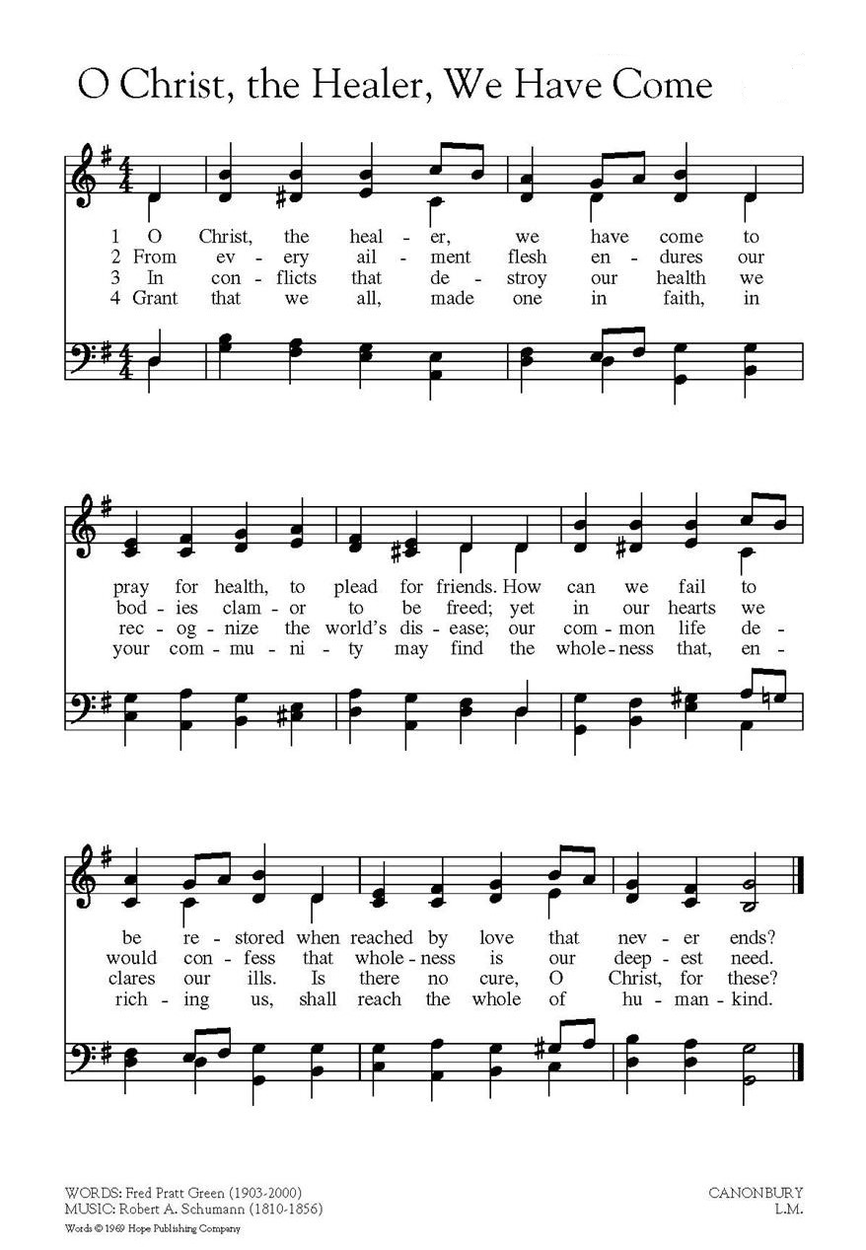

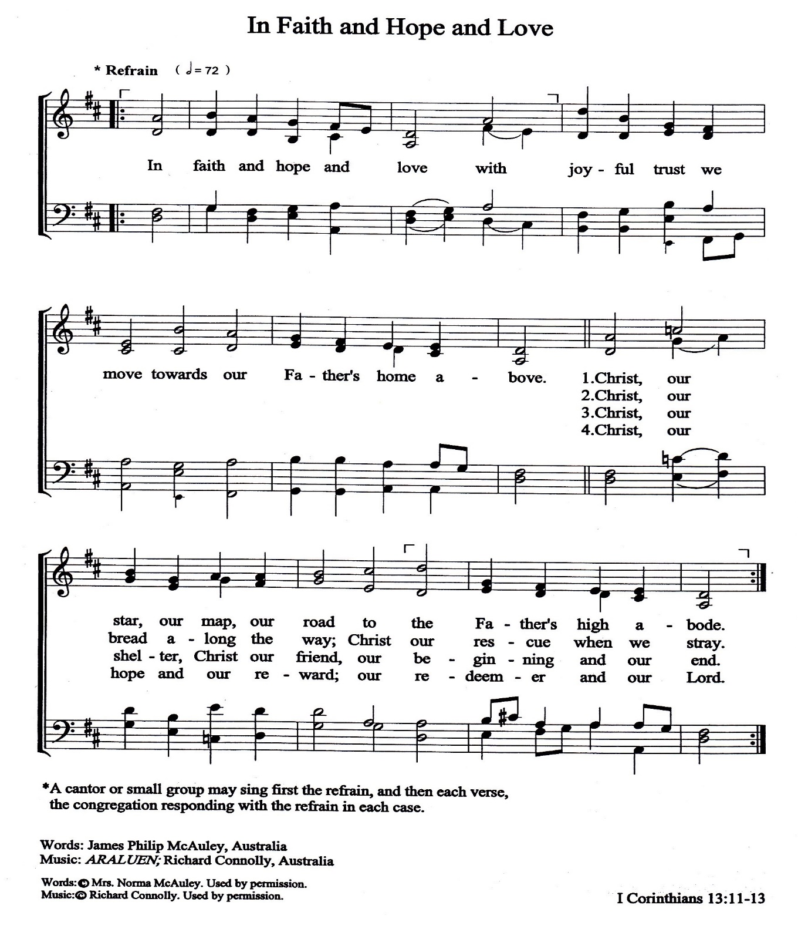

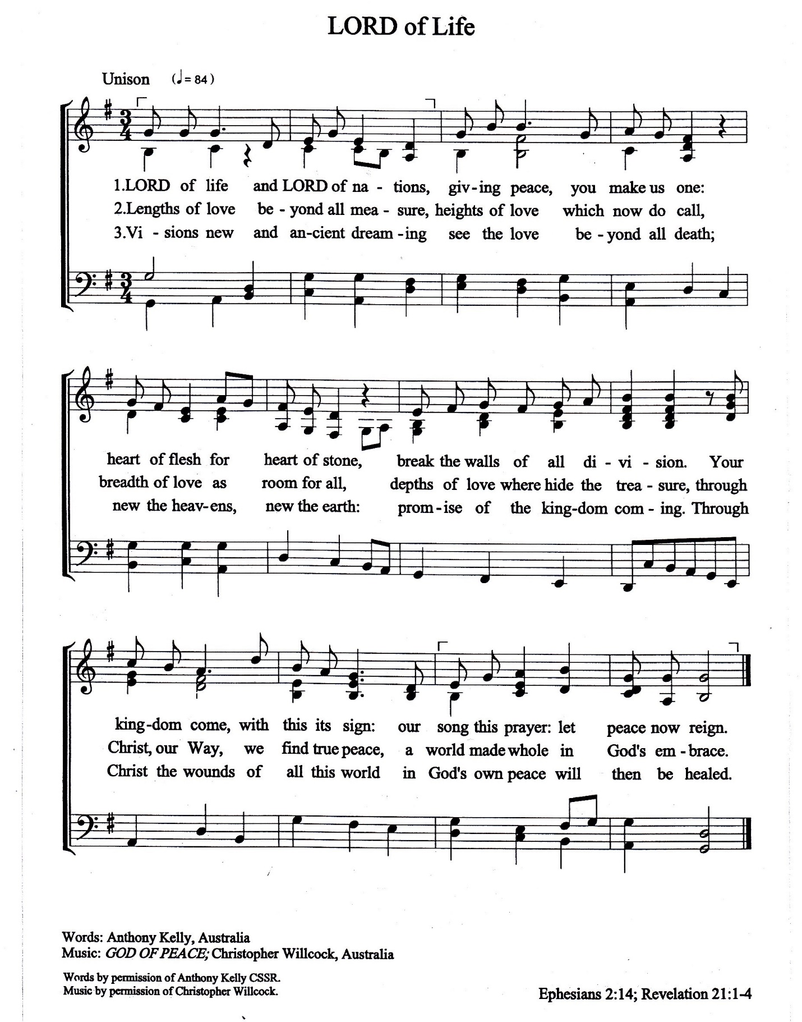

Resources
https://www.americamagazine.org/faith/
https://www.womansday.com/life/g25224950/healing-prayers/#sidepanel
https://episcopalchurch.org/files/prayers_and_liturgies_for_the_covid-19_pandemic.pdf
A Prayer Written by Rev. Stella E. Pattipeilohy

You are encouraged to make a special Asia Sunday

Offering and contribute to

CCA’s Asia Solidarity Relief Fund

CCA Bank Account Details
Account Name | : Christian Conference of Asia
Bank | : Han Seng Bank
Branch | : Hankow Road (4 Hankow Road Kowloon,
 | Hong Kong SAR, China)
Account No. | : 295-4-709594
Account Type | : Multi-currency Account
Swift Code | : HASEHKHH

